Jenkins Task

Task Description:
Launch jenkins and explore creating projects and users.

Installing open jdk-21 on Jenkins:
sudo apt-get update
sudo apt-get install openjdk-21-jdk
java --version
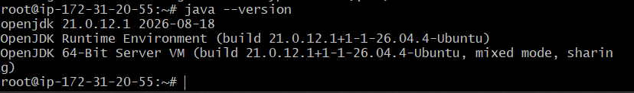

Install Jenkins:
sudo systemctl status jenkins
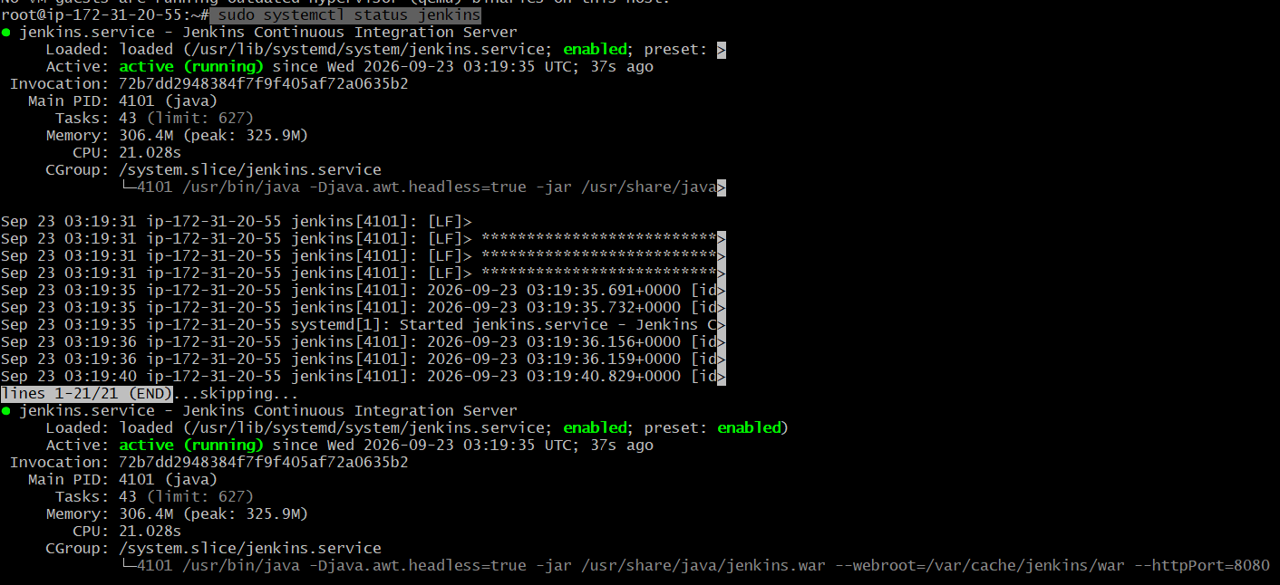

Launch Jenkins:

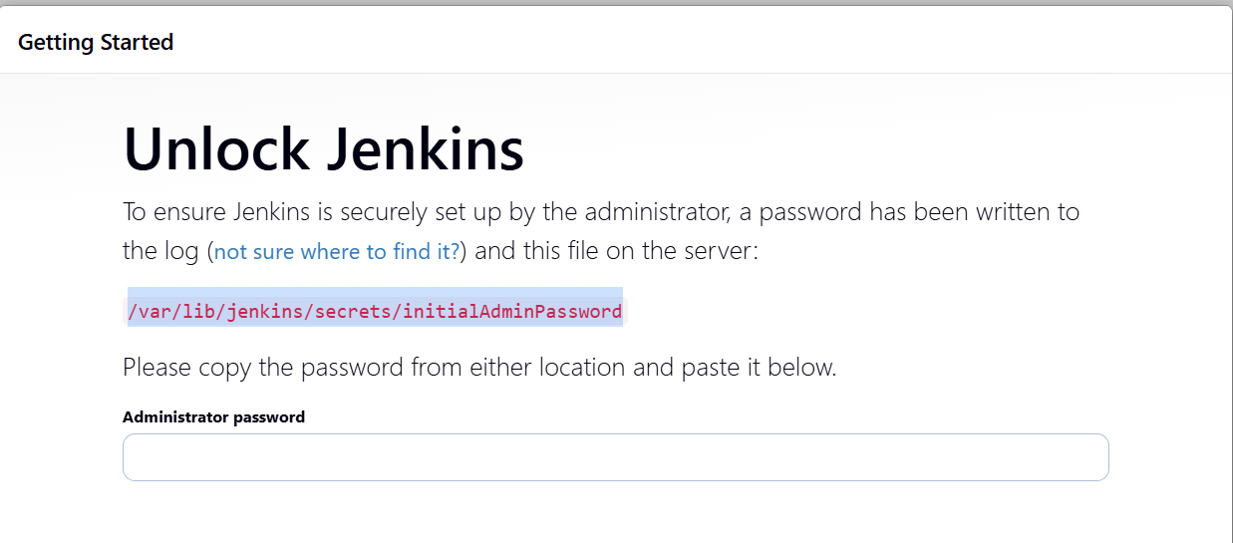

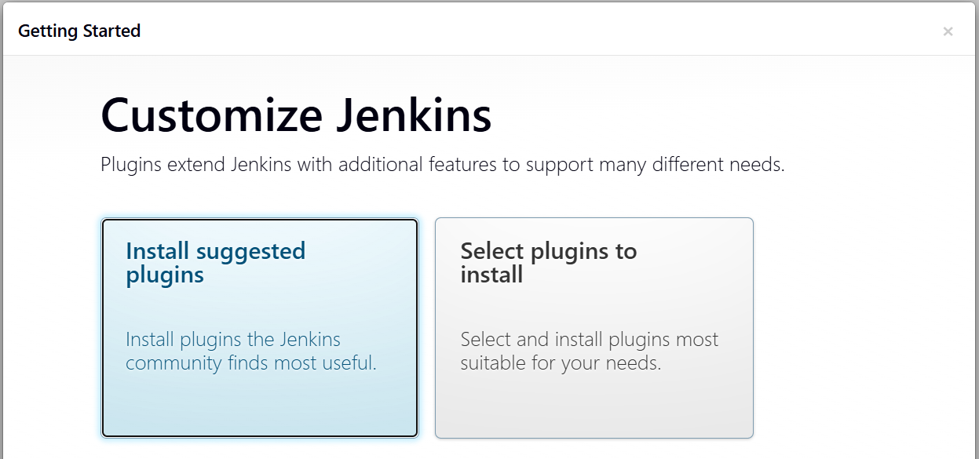

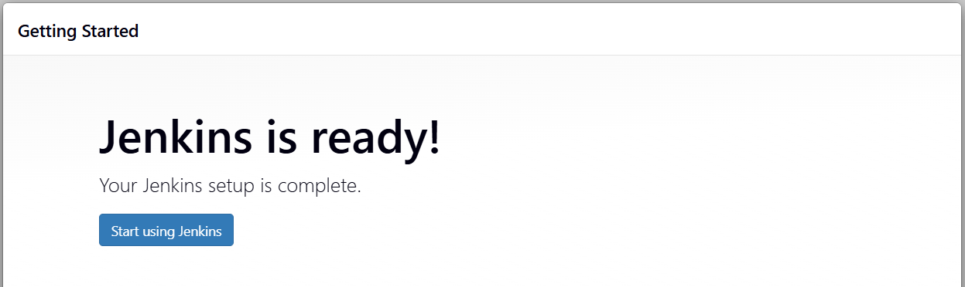
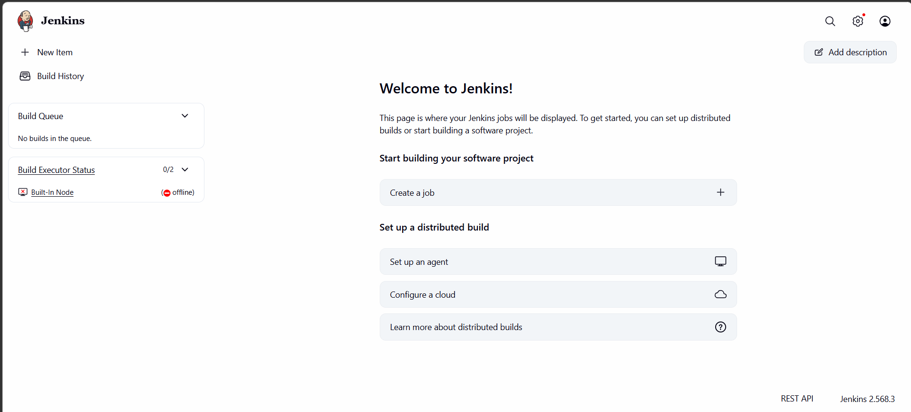

Create First Jenkins Project:

Creating pipe-line:
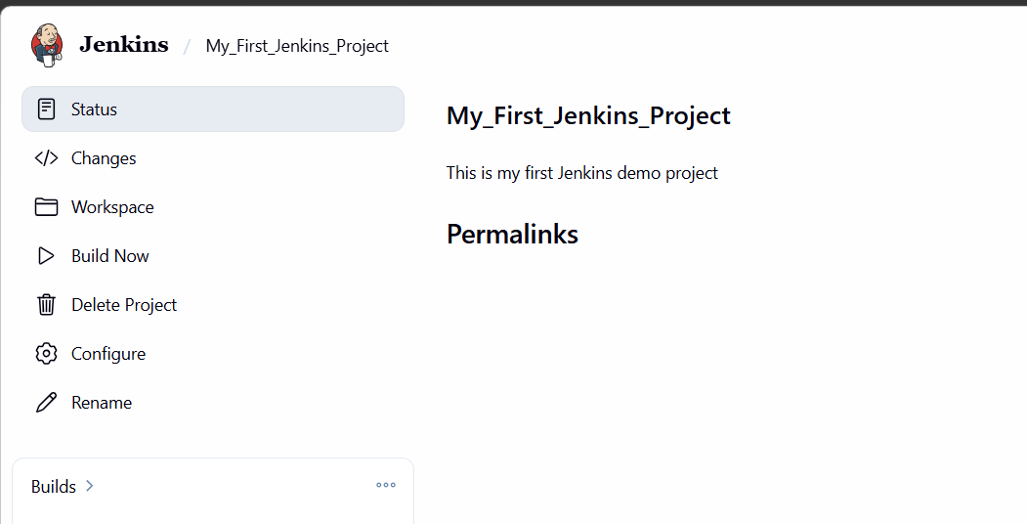
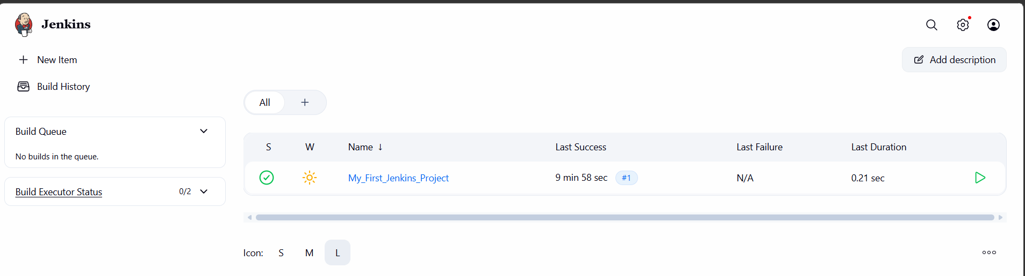

Build created Jenkins project:
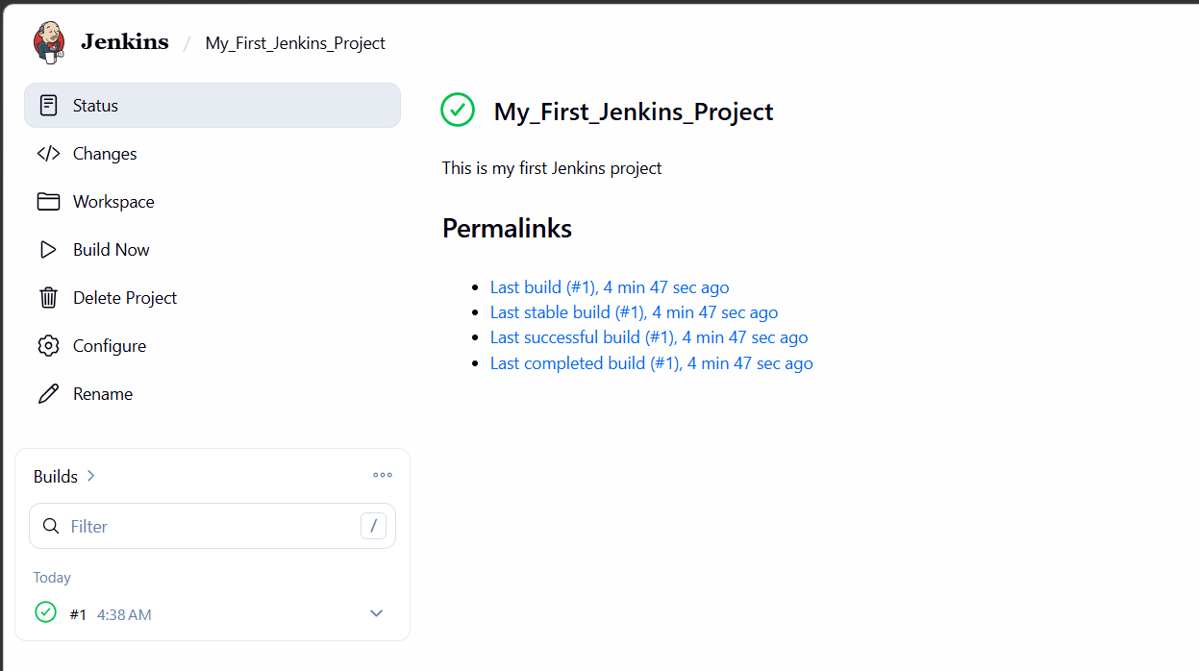

Build has been success:
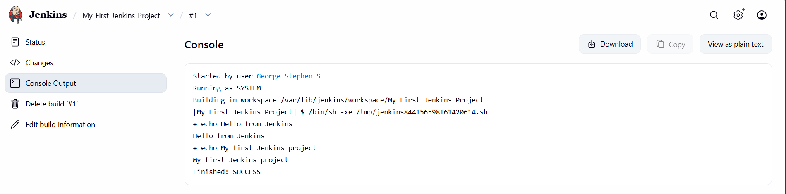

Create another user in Jenkins:
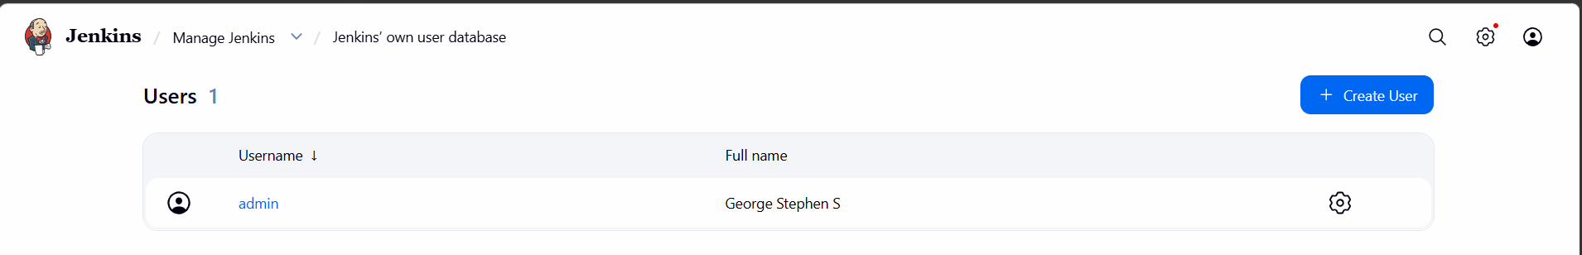
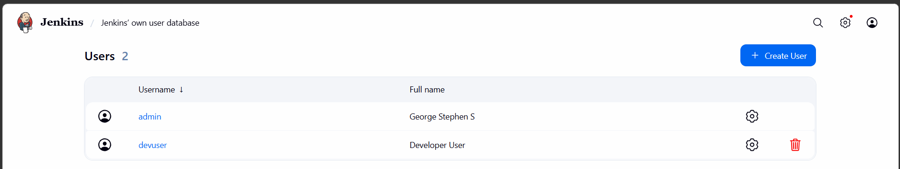
Loggin to the dev user:
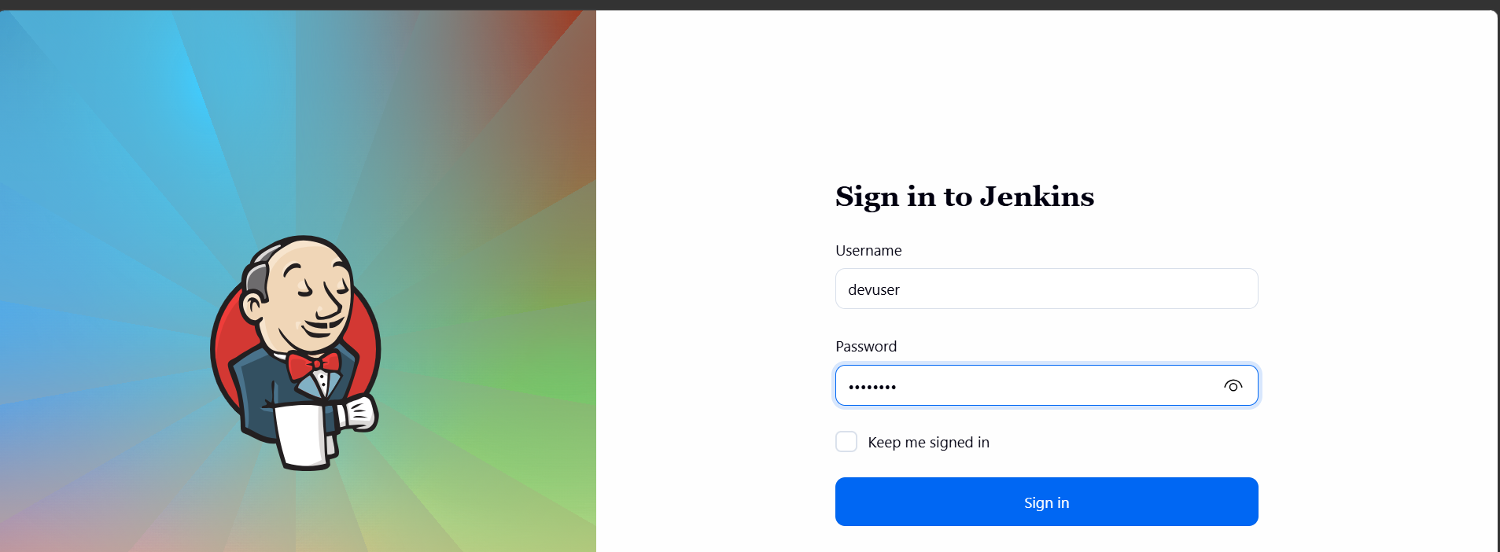
Logged in dev user:
